Name : Bolubanda Venkatesh

**Task:**

**Deploy application in monolithic and microservices architecture**

For monolithic : 1 EC2 instance, deploy wordpress and MYSQL on the same instances - For microservices: 2 EC2 instance, 1 for wordpress and 1 for MYSQL

**Instance specifications:**

Os : Ubuntu

**1, creating instance**

Take ubuntu as os t2 Micro, and launch instance

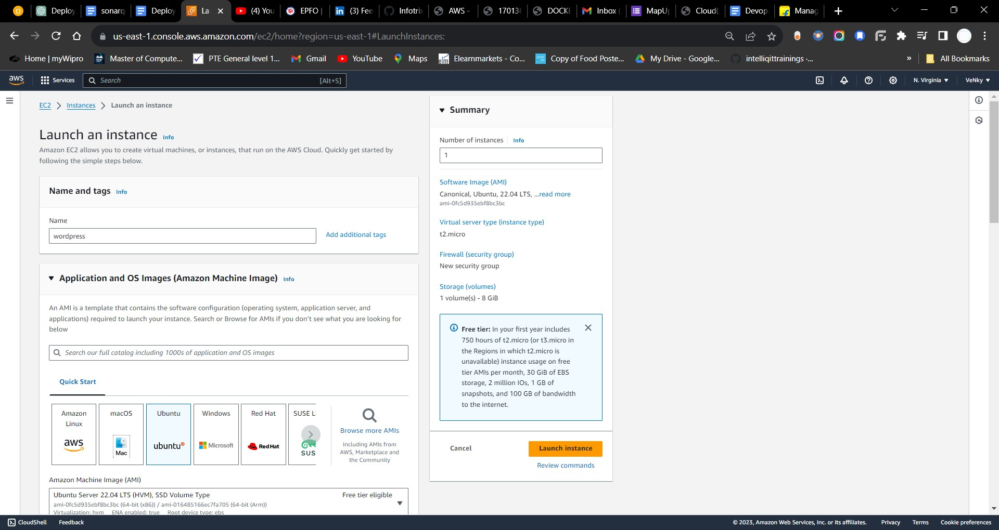

2, connect through git bash or putty

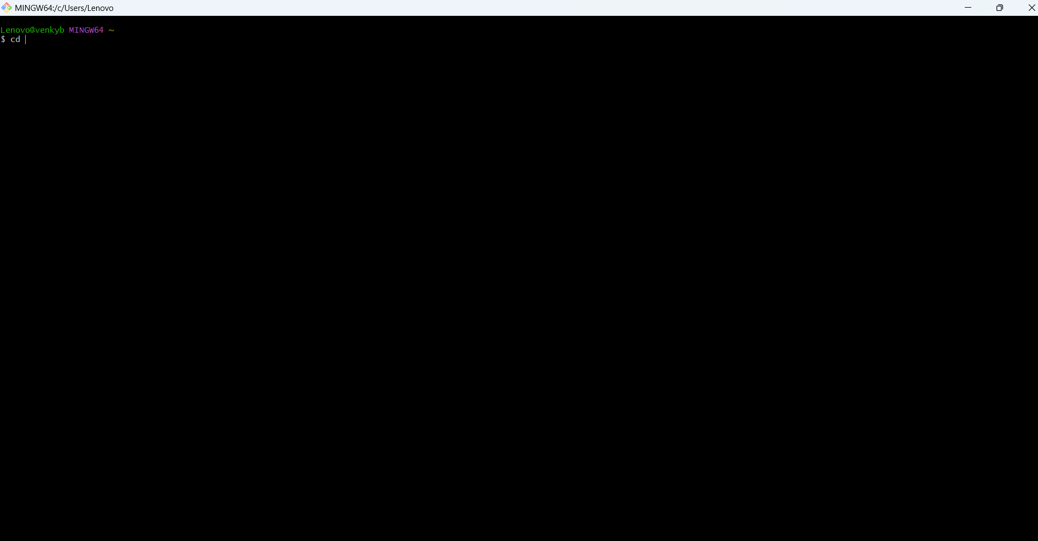

**Installing apache server on ec2**

* sudo apt install apache2

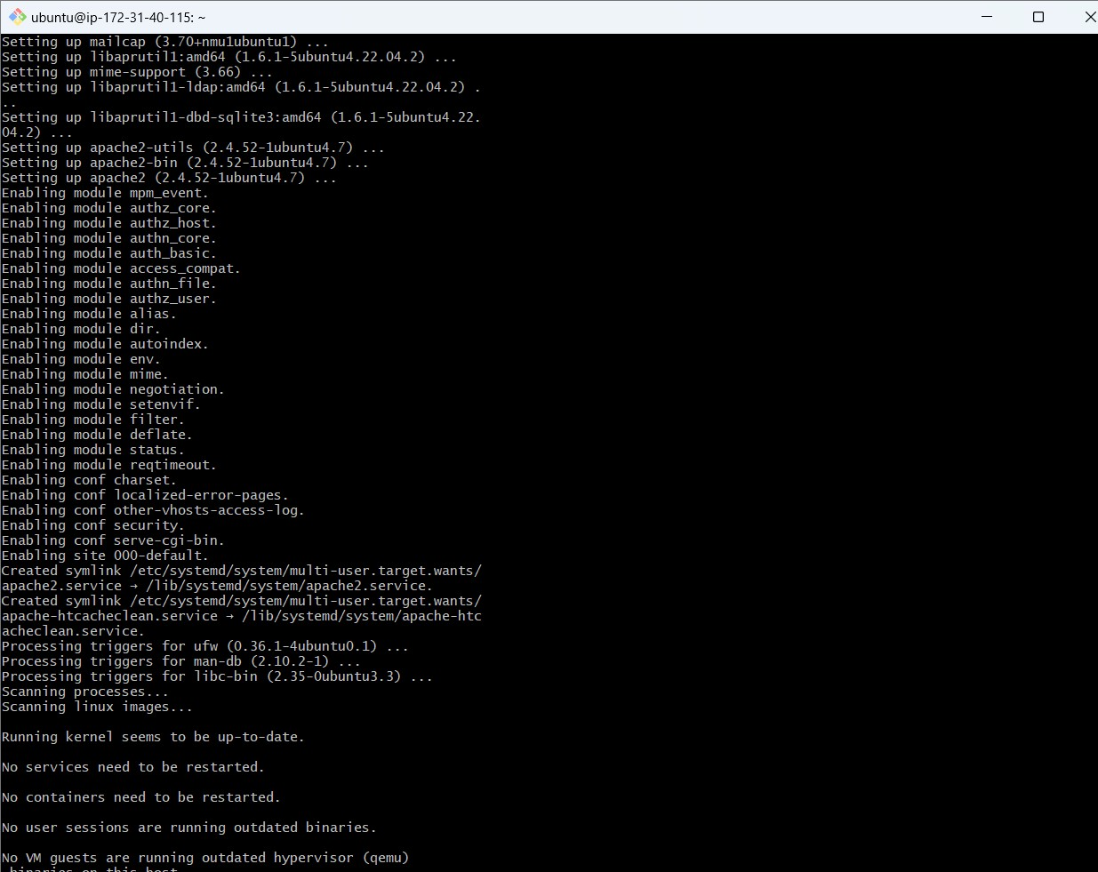

**Installing PHP and MYSQL connector**

* sudo apt install php libapache2-mod-php php-mysql

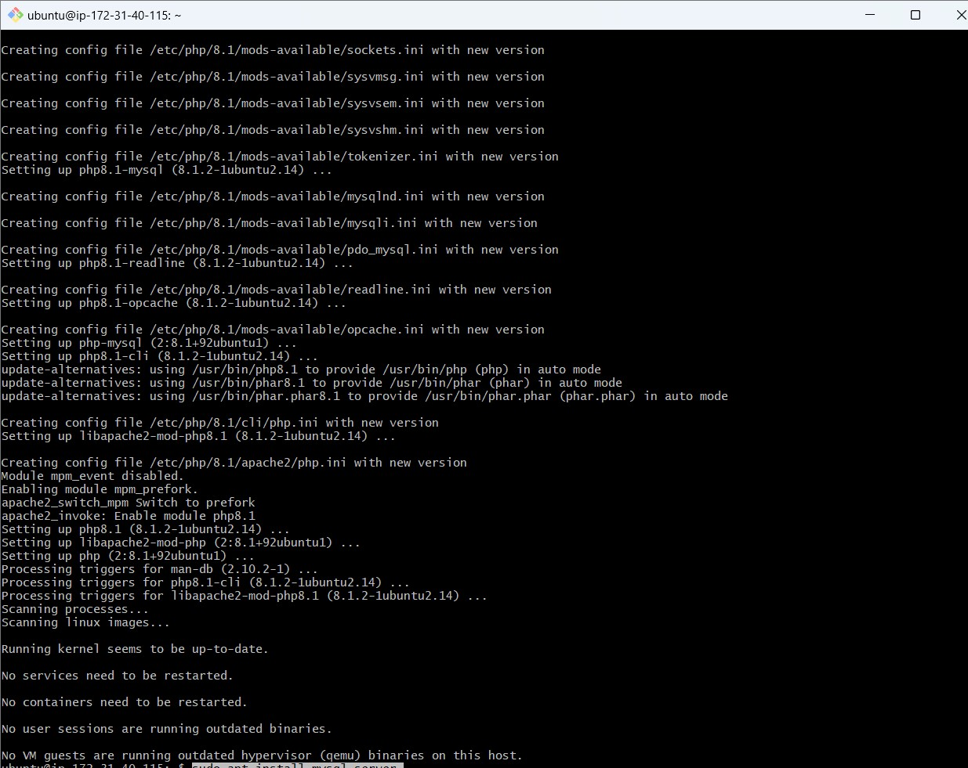

**Installing MYSQL server**

* sudo apt install mysql-server

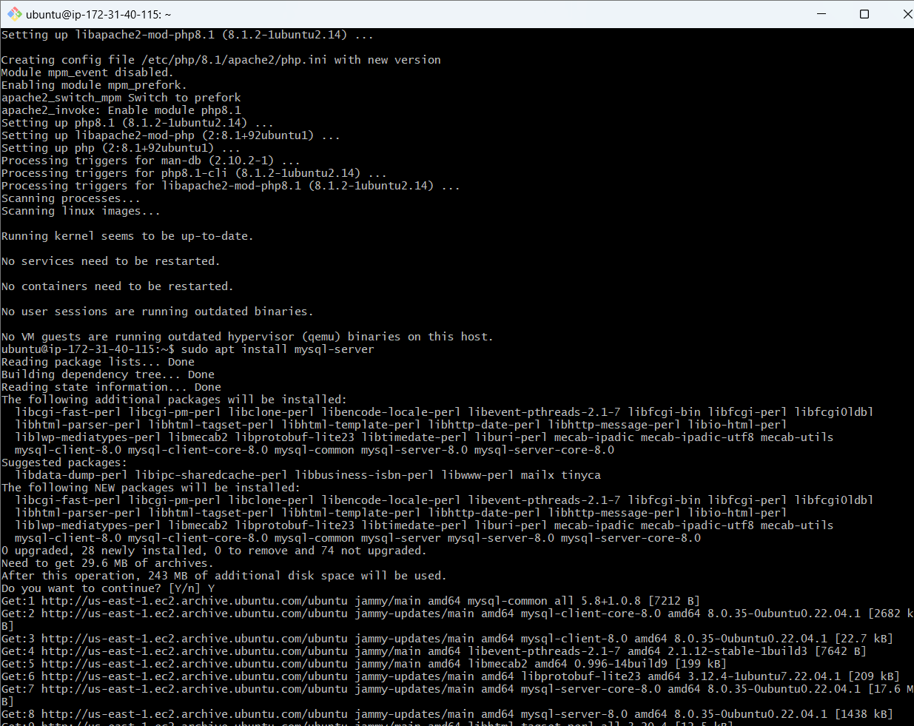

**Login to MySQL server**

* sudo mysql -u root

**Change authentication plugin to mysql_native_password**

* ALTER USER 'root'@'localhost' IDENTIFIED WITH mysql_native_password by 'venky123';

**Create a new database user for wordpress**

* CREATE USER 'wp_user'@localhost IDENTIFIED BY 'venky123';

**Create a database for wordpress**

* CREATE DATABASE wordpress;

**Grant all privilges on the database 'wordpress' to the newly created user**

* GRANT ALL PRIVILEGES ON wp.* TO 'wordpress_user'@localhost;

**Download wordpress:**

* **cd /tmp**
* **wget https://wordpress.org/latest.tar.gz**

**Unzip**

* **tar -xvf latest.tar.gz**

**Move wordpress folder to apache document root**

* sudo mv wordpress/ /var/www/html

**restart/reload apache server**

* sudo systemctl restart apache2

